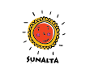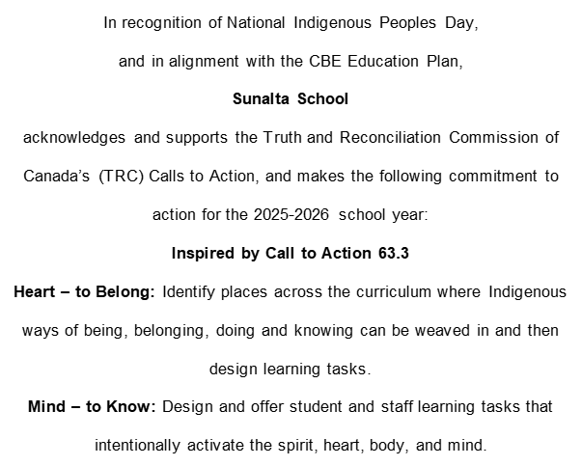
In recognition of National Indigenous Peoples Day,
and in alignment with the CBE Education Plan,
Sunalta School
acknowledges and supports the Truth and Reconciliation Commission of Canada’s (TRC) Calls to Action, and makes the following commitment to action for the 2026-2027 school year:
Body - To Do: Actively create opportunities for students, staff, and families to learn about and engage in Indigenous land-based and place-based learning.
Mind – to Know: Design and offer student and staff learning tasks that
intentionally activate the spirit, heart, body, and mind

Date: September 29, 2026

